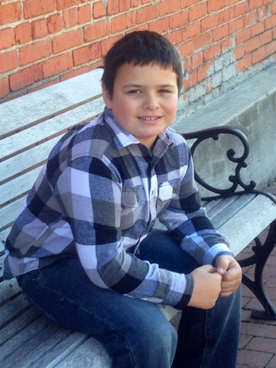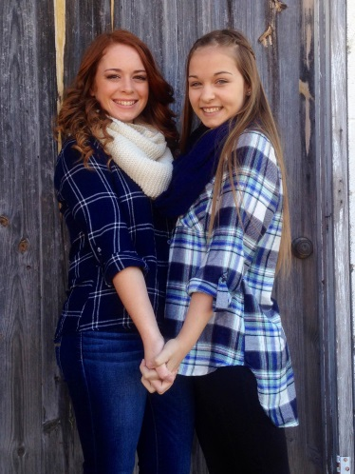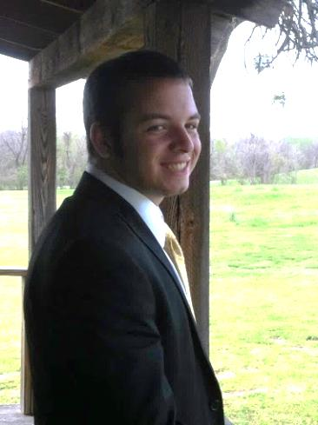
ALL ABOUT ME: Miss WoodHello!

After doing a long term sub in Pre-K for Mrs. Friend when she was on maternity leave having her baby, I discovered that I really wanted to be a teacher full time. My principal, Mrs. Holderby, encouraged me to do it, too because my co-workers and parents had been pleased with my work.
I prayed about it and after some soul searching - I felt that God was “calling” me at this time in my life to work with young children in the classroom. So, I went back to school and took college courses during the evening and summer … and within a year, I finished my goal! I earned a 4.0. I did it while working full-time plus part-time side jobs. I took my OGET, OSAT, and OPTE exams within 6 months and passed them. I am very proud of my accomplishments that have helped me reach my goal!!! I am extremely grateful for my mentor, Mrs. Jeraka Ireland, and all of my co-workers and teacher friends who encouraged me every step of the way. I love ya’ll!
I have 7 years of classroom experience and this is my second year being the teacher. I have taught in Mother’s Day Out and worked as an assistant and substitute for a handful of years. Plus, I’ve worked with the youth, young children, and nursery at church.
I was born and raised in Owasso, Oklahoma and I graduated from high school in 1988. I earned a Liberal Arts Degree from Tulsa Community College in 1990. I transferred to OSU in Stillwater and completed my Bachelor’s Degree in Public Relations & Journalism in 1992. Recently, I went back to attain my non-traditional paraprofessional route to teacher’s certification in Early Childhood Education from NSU in Broken Arrow, OK.
I have four children ranging in ages from 10 to 20 that I raise single-handedly. My oldest son, Logan, is serving a church mission in Riverside, California. My oldest daughter, Savannah, is a Senior this year. She loves to cheer and she also plays flute in band. She makes good grades and plans to go to OSU. My youngest daughter, Rachel, also loves to cheer. She will be a Freshman this year. She’s super smart with straight A’s and super sweet too! Your children will likely get to know her because she likes to stop by after school. Gideon, who is my youngest son, is going into the 5th grade. He LOVES football and wrestling. He also enjoys cub scouts.
I have three four-legged fur babies: I have 2 dogs: Bruce and Dixie plus I have a cat named Stetson.
My hobbies include: being creative and crafty, pinning school ideas, watching a funny movie or playing a game with my kids, cooking a yummy meal for my family, reading a good book and relaxing, working out with my kids, sitting on my back porch and watching the squirrels and birds while feeling the cool breeze, and making memories with my family and friends.
Some silly side notes: One of my favorite things to do is to jot down the funny things the kids say so that I can remember them and giggle.
I love to drink water and lemonade – they’re my favorites and from time to time you’ll catch me with a Route 44 Vanilla Dr. Pepper as a special treat but I’m just as happy with a blackberry / lemon / mint water.
Finally, please know that I love FTG PK! This is my 6th year here at Fort Gibson Public School District. I LOVE being a teacher and I’m excited about working with your child and helping them learn and grow.
Miss Larissa M. Wood, PK Teacher

